**HelpMe – Android Application Manual**

**1. INTRODUCTION:**

HelpMe is a lightweight application that is supposed to get help in one click.The Android Application which is expected to be published at the [play store](https://play.google.com) of Google. The Application would be available for free.

**2. PERMISSIONS REQUIRED:**

The permissions required for this application are:

1. Location Information
2. Cell Phone Information
3. Internet Access permission

**3. APPLICATION INTERFACE/COMPONENTS:**

The application has the following components

1. TextViews
2. EditText
3. Button

**3.1 TextViews**

TextViews are components to display raw texts. There are three TextViews used in the application. It is used for

1. Showing phone number

2. Showing Message title



3. Showing the location

This Textview is changes itself after getting the location of the latitude and longitude into the following one:



**3.2 Edit Text**

The EditText is used to get the input text entered into the box. There is one EditText used in this application. It is used to get the “message” that the user wants to send.



**3.3 Button**

The Button is used to send the content information to the server. There is one button used in this application. The message is box is optional and so when theuser clicks the “Help Me” button the information is passed into the servr

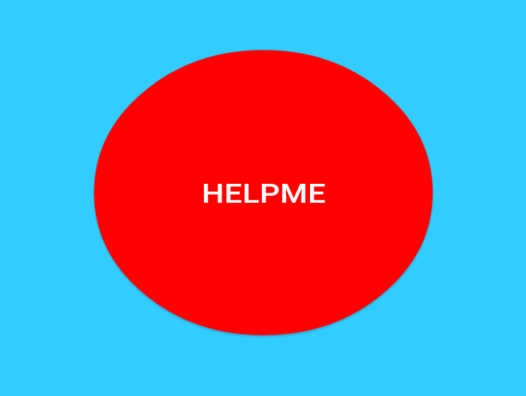

**4. EXPECTED RESULT:**

The application is supposed to feature the following

1. Fluid Navigation
2. One touch help
3. Automatic location gathering
4. Automatic phone number gathering

The information from the app is passed to the server where the further processing is done. The expected screen of the application is shown below:

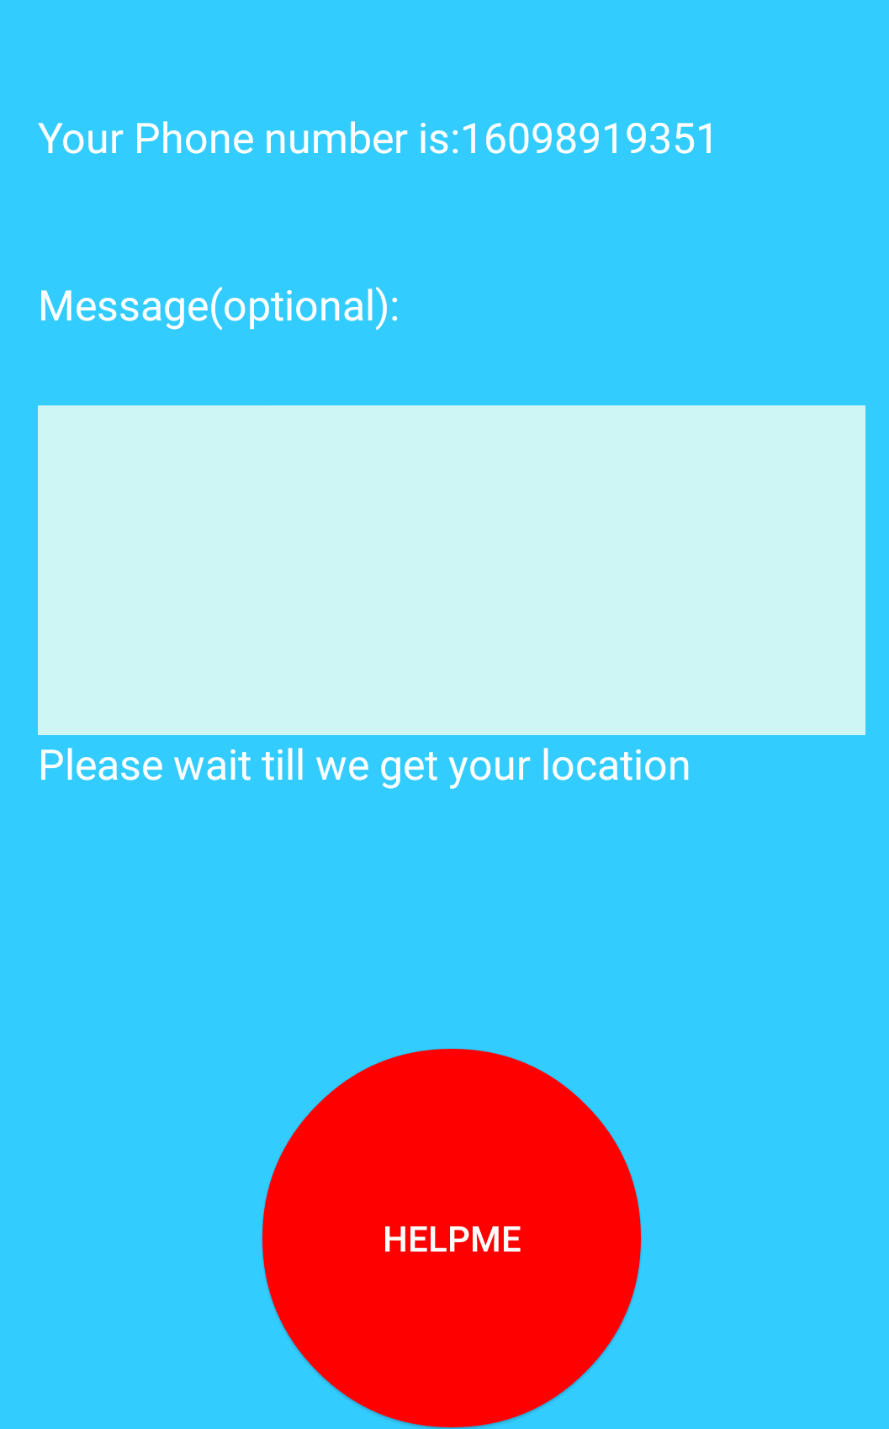

**5. CONCLUSION:**

The application UI is expected to be a single touch in its minimal feature and can connect the requesters with the helping counterparts.